Tool: User Manual

A Non-technical User Guide

Ian Field

Table of Contents

Introduction 3

Setup 3

Database connection 3

Locales 4

Database 5

# Introduction

This tool has been created to be a flexible platform for gathering result sets from public participation of content. For example, a block of text can be presented on the web page, beneath that a series of check boxes will be shown with values associated with the text. This could be used as an assessment platform to analyze human input or reaction.

Ideally this is to be used to locate the individual items and percentages of three option groups based on a presented piece of text. The tool supports the possibility of one option being present within more than one of the groups by merging the option into one on the web page, but updating the database with each occurrence.

The tool supports multiple languages with a few elements of user customization throughout to cater for your unique needs.

# Setup

This tool is designed to run on a web server, with requirements of PHP and MySQL in order to function. It is best to contact your service provider in order to obtain the details of this.

Provided that the compressed tool is in possession it must first be extracted before use. Right clicking on the archive and clicking ‘Extract’ can achieve this.

## Database connection

Your service provider should provide you with the host name or address of your database provider. This may also include a port number. Along with this information should be a database username and password.

Within the extracted folder navigate to the following location: *html > db_conn*.

In this folder you will notice 3 files. In order to set up the database connection the file named ‘*config.php*’ must be edited. To do so a standard text editor is required. For Windows this would be Notepad, or on Macintosh this would be TextEdit. Open these applications first. Then open the ‘*config.php*’ file.

The file should look something like this:

<?php

$dbhost = 'localhost:8889';

$dbname = 'survey';

$dbuser = 'root';

$dbpass = 'root';

?>

Each indented line is a configuration item used to connect to your database. Within the single quotation marks please replace the relevant information. Notice that the host has the ending ‘:8889’, this number is the port that may have been provided to you by your service provider. If not provided, remove ‘:’ and any numbers following it.

## Locales

The tool supports language customization to meet your target audience’s needs. These are altered in a similar manner to above. The content of the ‘About’ page can be specified within *html > config > about.php*. This is essentially a text file however, feel free to add any extra HTML tags you require for your desired display.

Within the same folder is another file with a similar format to the database configuration file. Here you may customize the about page title and navigation link text.

Below is an example set up for English:

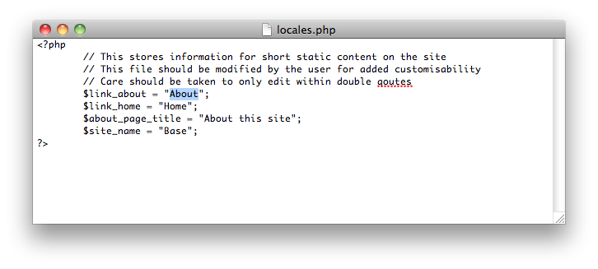

Please take care when altering this file that the changes are made within the double quotation marks only as a mistaken character deletion may cause an error on the web pages. Here the about link text is highlighted for a demonstration on where to edit. Please use this image to refer back to should an error occur, or failing that please copy and paste the same file from another extracted zip file.

With the help of your hosting provider, or someone experienced this process can be streamlined. Unfortunately due to the nature of web hosting there is no ultimate guide for how to do this.

The files in the html folder should be included in the public web directory on your hosting solution.

To set up the database to be ready for use locate the file DB > setup.sql. This should then be executed on the database server to serve as an all-in-one setup process.

Next visit your website and you can begin using it straight away with the first pre-populated example database entries. Once you have a feel for how the site is laid out you’re ready to populate your database.

# Database

The database does not store user information past that of their IP address, which can later be used to remove spam or erroneous entries within your database. So you can feel free to state this in the about page to reassure your participants.

Care has been taken to ensure that despite displaying the options in alphabetical order with no duplicates, they still correctly correspond to the same locations within the database.

It is expected that once the database has been populated, it will not be altered again until the experiment period is completed, after which its expected that the database will be rebuilt.